

**East Delta University**

**Experiment Name:** Implementation of

**Name:** Pranesh Chowdhury

**ID:** 202003112

**Section:** 02

**Instructor Name:** Tasnimatul Jannah

**Course Name:** CSE 322 Computer Graphics Lab

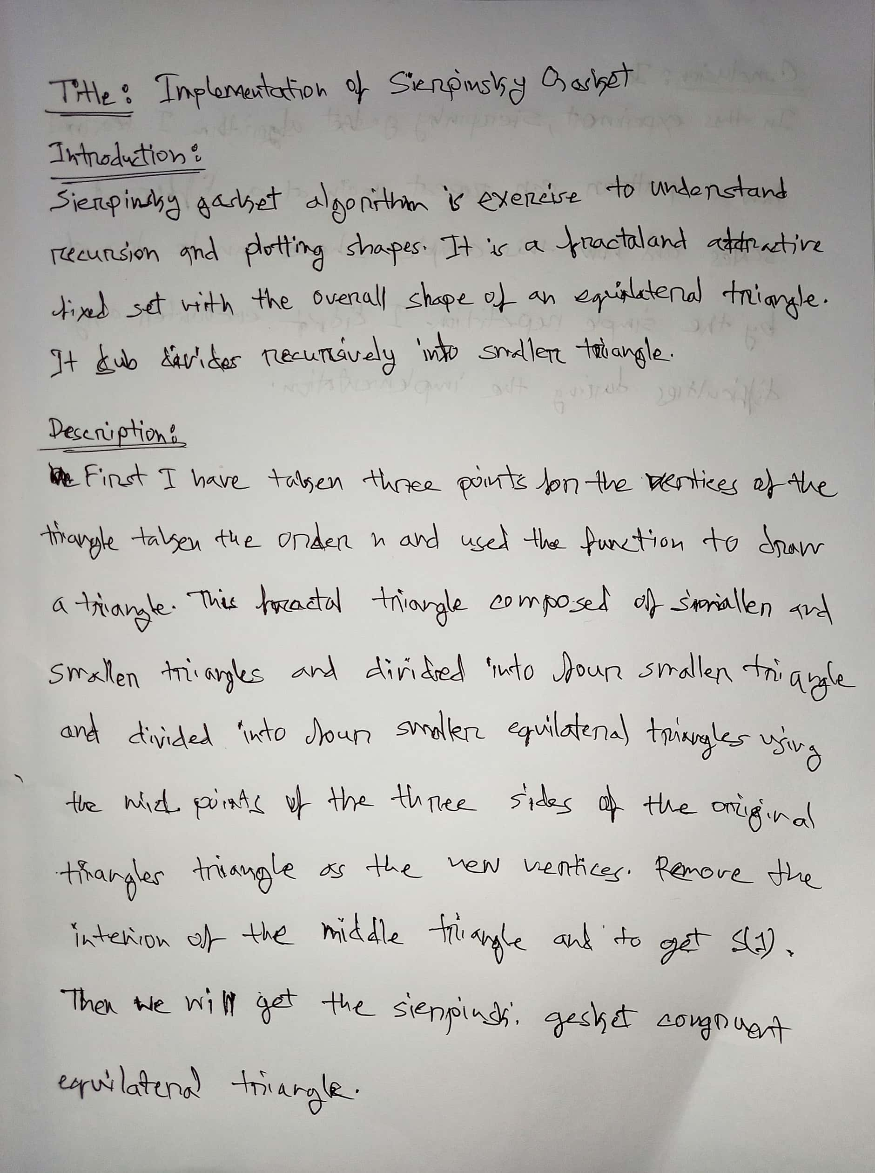

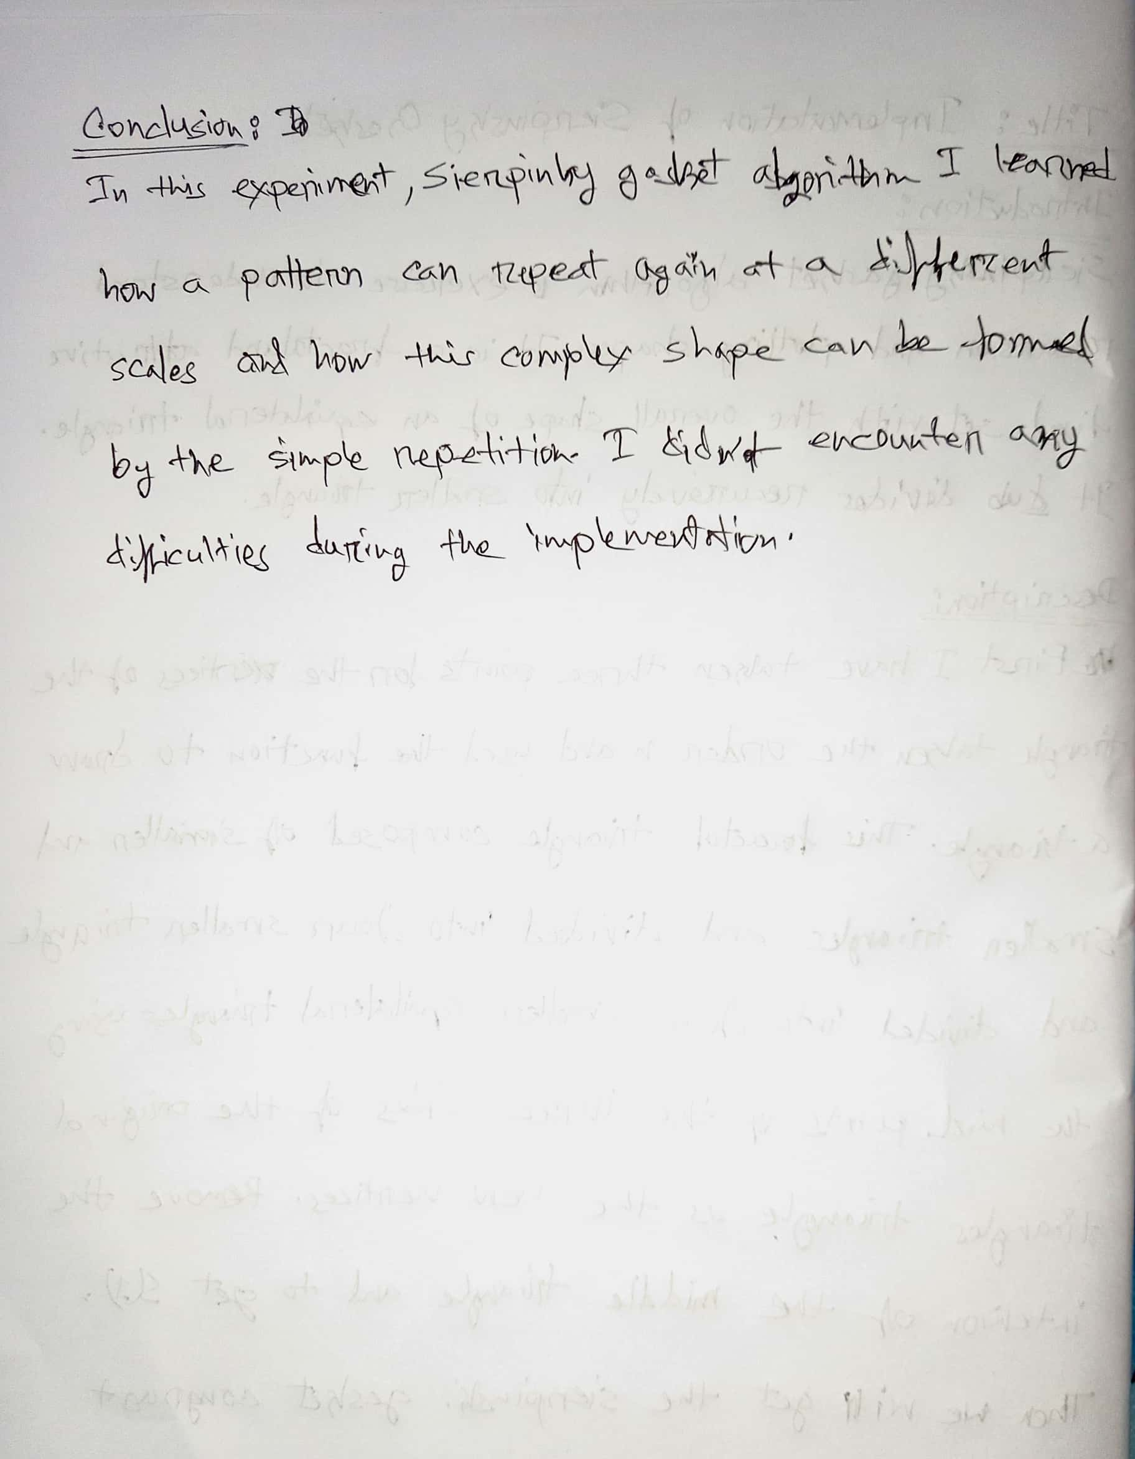

**Code:**